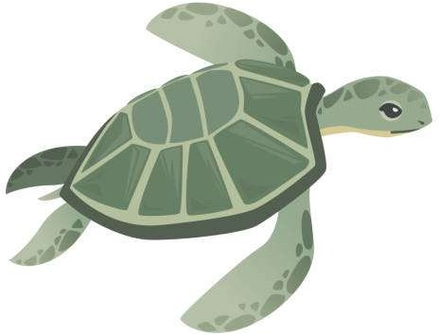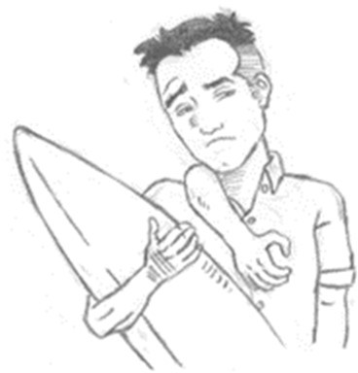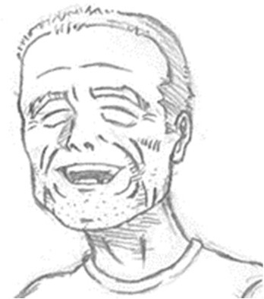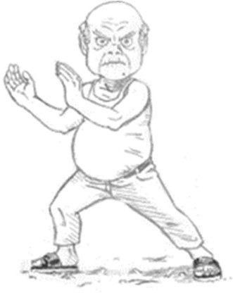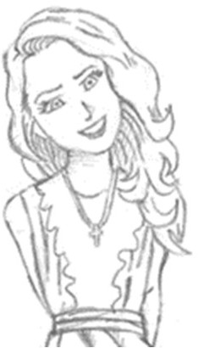

My Best Friend Looks Like an Island

*Name:*

*Seat Number: Class:*

暑假作業說明

暑假作業分為兩部份，第一部份為小說讀後心得，第二部份為雜誌學習筆記。開學後請繳交給英文老師（紙本或電子檔，請依高二英文老師要求）。

【第一部份**—**小說讀後心得】

請閱讀完 *My Best Friend Looks Like an Island* 後，根據書中內容以英文回答相關問題，問答題請以完整句作答。

【第二部份**—**雜誌學習筆記】

請閱讀 All+ 七月號雜誌，並從中選取 **5** 個單元，每一個單元完成一張**Listening Journal**。請務必填寫清楚單元編號、名稱。在每一個單元中請選出**5** 句你覺得值得學習的句子，並聽雜誌廣播老師的講解，寫下重點。另外，請

於該單元的文章中，選出 **4** 個重點單字，再依指示完成單字筆記。

**Question 1: Match the characters to their pictures and descriptions**

1. **Kobi** (The teenage hero of the story)
2. **Ro** / Ro-Ro Gway-Gway (A special turtle and Kobi’s best friend)
3. **Ye-Ye** (Kobi’s grandfather, a wise and kind old man)
4. **Milkshake** (Kobi’s pineapple-headed classmate and 2nd best friend)
5. **Ting-Ting** (The artistic girl who Kobi secretly likes)
6. **Mr. Wu** (Kobi and Ye-Ye’s retired neighbor and Taiqi enthusiast)
7. **______ Brother Liao** (Local surf shop owner with many bad habits)
8. **______ Officer Wang** (Police officer and the school principal’s husband)
9. **Auntie Guo** (Librarian with lots of different talents and interests)
10. **Dr. Qing** (The best dentist in the county)
11. **Hannah Kloss** (A beautiful exchange student from Switzerland)
12. **Herr Kloss** (Hannah’s chubby, chocolate-loving father)

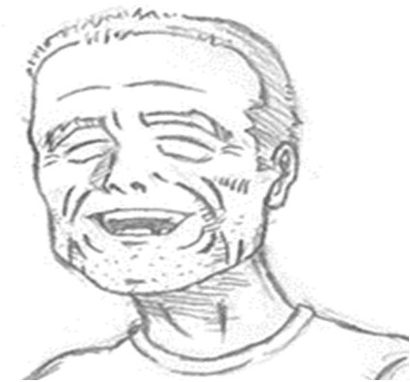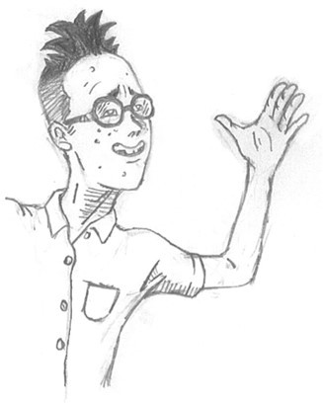A.

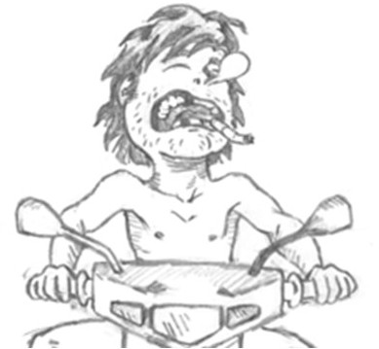

B.

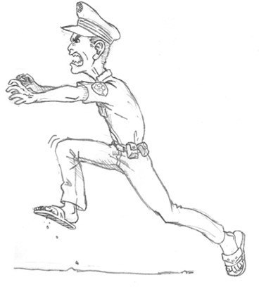

C.

D.

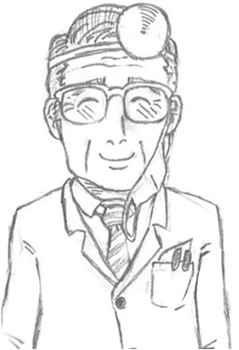G.

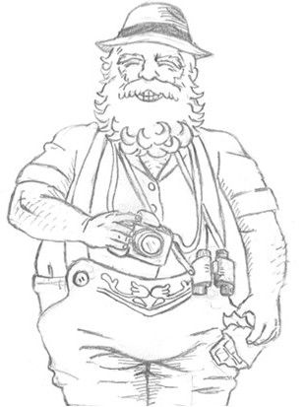

E.

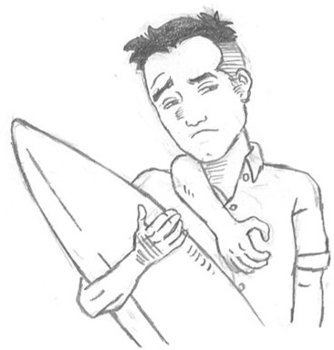

F.

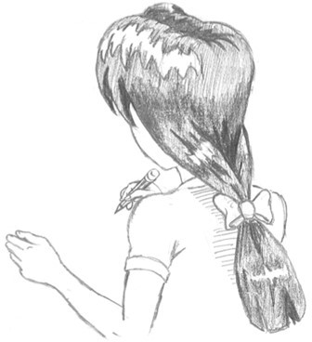

H.

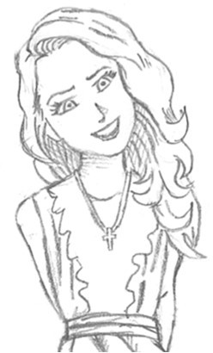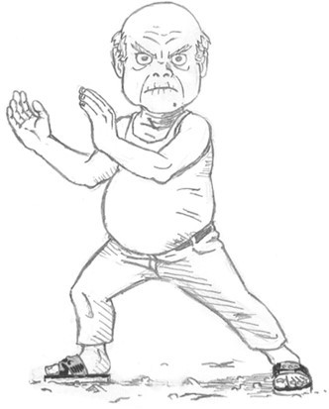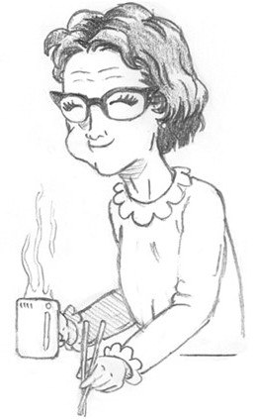I. J. K. L.

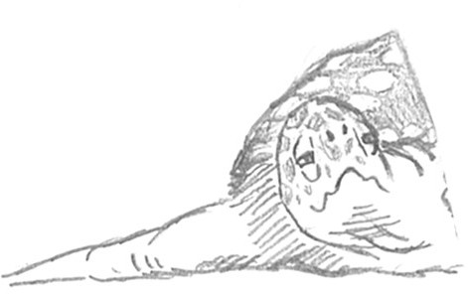

**Question 2.** In Chapter 1, Kobi says: “I’ve always had Ye-Ye, Ro and the sea and I’ve always loved all three. They’re all easy to love. I think it’s because they

somehow stay the same even though they’re constantly changing.” **What do you think he means by the last sentence?**

**Question 3. Please answer the following questions based on the story.**

1. What does “FCF” stand for?
2. Why did Ting-ting visit Kobi’s house?
3. What’s the relationship between Mr. Kloss and Hannah?
4. What did Mr. Wu ask Kobi to do in relation to Mr. Wang?

**Question 4.** Why do you think the author made Kobi’s best friend a turtle? And does “**look like an island**” hold any underlying messages?

**Question 5.** In the story, Kobi and Milkshake fell in love with the same girl, Ting- Ting. If you were faced with the same situation, what would you do?

**Question 6.** In chapter 22, Nai-Nai told Kobi that nothing ever disappears, it just changes into something else. Now, please try to recall a time you lost something

you cared a lot (could be actual objects or abstract relationships), what emotions did this experience bring to you and how did you move on?

# English Magazine Listening Journal ①

**Class: Name: No.**

|  |  |  |  |  |
| --- | --- | --- | --- | --- |
| **Unit**  **請填入單元編號，聆聽廣播講解，並完成筆記)** | | **Title of the article**:  ***Read the article aloud*** *before you listen to the radio program!* | | |
| **Main idea**  (use one sentence to summarize the article) | |  | | |
| **Notes**  Choose five sentences that you think are important from the passage of this unit. What have you learned from the listening program about these five sentences? Jot down what the teachers say. 選出雜誌單元文章內容中，你覺得重要的句子。廣播老師是如何解說的呢？寫下老師  解說的關鍵字，或是為何這句很重要（可以是文法/句子結構/句子解釋等等）。 | | | | |
|  | **Sentence** | | **Explanation from the teacher** |  |
|  | ❶ | |  |  |
|  | ❷ | |  |  |
|  | ❸ | |  |  |



❹

❺

**Vocabulary**

Pick **four** words or phrases you have learned from this unit and make full sentences. **Write** in the space down below and **highlight** the newly learned words or phrases. 挑選單元4個單字，先寫詞性、英文和中文定義，再造句。若例句實用，也可抄寫雜誌例句

* highlight (v.) to emphasize something, especially so that people give it more attention [強調、突顯] Our PE teacher highlighted the importance of exercise to stay healthy.

① _

_

② _

_

③

_

④ _

# English Magazine Listening Journal ②

**Class: Name: No.**

|  |  |  |  |  |
| --- | --- | --- | --- | --- |
| **Unit**  **請填入單元編號，聆聽廣播講解，並完成筆記)** | | **Title of the article**:  ***Read the article aloud*** *before you listen to the radio program!* | | |
| **Main idea**  (use one sentence to summarize the article) | |  | | |
| **Notes**  Choose five sentences that you think are important from the passage of this unit. What have you learned from the listening program about these five sentences? Jot down what the teachers say. 選出雜誌單元文章內容中，你覺得重要的句子。廣播老師是如何解說的呢？寫下老師  解說的關鍵字，或是為何這句很重要（可以是文法/句子結構/句子解釋等等）。 | | | | |
|  | **Sentence** | | **Explanation from the teacher** |  |
|  | ❶ | |  |  |
|  | ❷ | |  |  |
|  | ❸ | |  |  |



❹

❺

**Vocabulary**

Pick **four** words or phrases you have learned from this unit and make full sentences. **Write** in the space down below and **highlight** the newly learned words or phrases. 挑選單元4個單字，先寫詞性、英文和中文定義，再造句。若例句實用，也可抄寫雜誌例句

* highlight (v.) to emphasize something, especially so that people give it more attention [強調、突顯] Our PE teacher highlighted the importance of exercise to stay healthy.

① _

_

② _

_

③

_

④ _

# English Magazine Listening Journal ③

**Class: Name: No.**

|  |  |  |  |  |
| --- | --- | --- | --- | --- |
| **Unit**  **請填入單元編號，聆聽廣播講解，並完成筆記)** | | **Title of the article**:  ***Read the article aloud*** *before you listen to the radio program!* | | |
| **Main idea**  (use one sentence to summarize the article) | |  | | |
| **Notes**  Choose five sentences that you think are important from the passage of this unit. What have you learned from the listening program about these five sentences? Jot down what the teachers say. 選出雜誌單元文章內容中，你覺得重要的句子。廣播老師是如何解說的呢？寫下老師  解說的關鍵字，或是為何這句很重要（可以是文法/句子結構/句子解釋等等）。 | | | | |
|  | **Sentence** | | **Explanation from the teacher** |  |
|  | ❶ | |  |  |
|  | ❷ | |  |  |
|  | ❸ | |  |  |



❹

❺

**Vocabulary**

Pick **four** words or phrases you have learned from this unit and make full sentences. **Write** in the space down below and **highlight** the newly learned words or phrases. 挑選單元4個單字，先寫詞性、英文和中文定義，再造句。若例句實用，也可抄寫雜誌例句

* highlight (v.) to emphasize something, especially so that people give it more attention [強調、突顯] Our PE teacher highlighted the importance of exercise to stay healthy.

① _

_

② _

_

③

_

④ _

# English Magazine Listening Journal ④

**Class: Name: No.**

|  |  |  |  |  |
| --- | --- | --- | --- | --- |
| **Unit**  **請填入單元編號，聆聽廣播講解，並完成筆記)** | | **Title of the article**:  ***Read the article aloud*** *before you listen to the radio program!* | | |
| **Main idea**  (use one sentence to summarize the article) | |  | | |
| **Notes**  Choose five sentences that you think are important from the passage of this unit. What have you learned from the listening program about these five sentences? Jot down what the teachers say. 選出雜誌單元文章內容中，你覺得重要的句子。廣播老師是如何解說的呢？寫下老師  解說的關鍵字，或是為何這句很重要（可以是文法/句子結構/句子解釋等等）。 | | | | |
|  | **Sentence** | | **Explanation from the teacher** |  |
|  | ❶ | |  |  |
|  | ❷ | |  |  |
|  | ❸ | |  |  |



❹

❺

**Vocabulary**

Pick **four** words or phrases you have learned from this unit and make full sentences. **Write** in the space down below and **highlight** the newly learned words or phrases. 挑選單元4個單字，先寫詞性、英文和中文定義，再造句。若例句實用，也可抄寫雜誌例句

* highlight (v.) to emphasize something, especially so that people give it more attention [強調、突顯] Our PE teacher highlighted the importance of exercise to stay healthy.

① _

_

② _

_

③

_

④ _

# English Magazine Listening Journal ⑤

**Class: Name: No.**

|  |  |  |  |  |
| --- | --- | --- | --- | --- |
| **Unit**  **請填入單元編號，聆聽廣播講解，並完成筆記)** | | **Title of the article**:  ***Read the article aloud*** *before you listen to the radio program!* | | |
| **Main idea**  (use one sentence to summarize the article) | |  | | |
| **Notes**  Choose five sentences that you think are important from the passage of this unit. What have you learned from the listening program about these five sentences? Jot down what the teachers say. 選出雜誌單元文章內容中，你覺得重要的句子。廣播老師是如何解說的呢？寫下老師  解說的關鍵字，或是為何這句很重要（可以是文法/句子結構/句子解釋等等）。 | | | | |
|  | **Sentence** | | **Explanation from the teacher** |  |
|  | ❶ | |  |  |
|  | ❷ | |  |  |
|  | ❸ | |  |  |



❹

❺

**Vocabulary**

Pick **four** words or phrases you have learned from this unit and make full sentences. **Write** in the space down below and **highlight** the newly learned words or phrases. 挑選單元4個單字，先寫詞性、英文和中文定義，再造句。若例句實用，也可抄寫雜誌例句

* highlight (v.) to emphasize something, especially so that people give it more attention [強調、突顯] Our PE teacher highlighted the importance of exercise to stay healthy.

① _

_

② _

_

③

_

④ _